Sphere of Revolution
# Source: AI Source: Provided by: [Data Path: Persons Table -> ID Column: 1, Name_En Column: Motasem Essam] -> From: [ChatGPT] on [7/25/2026]
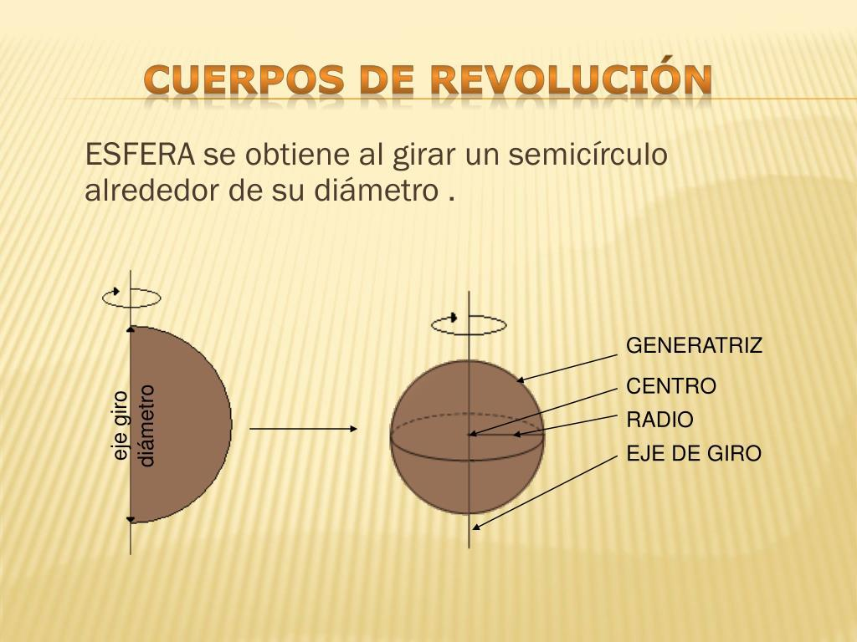
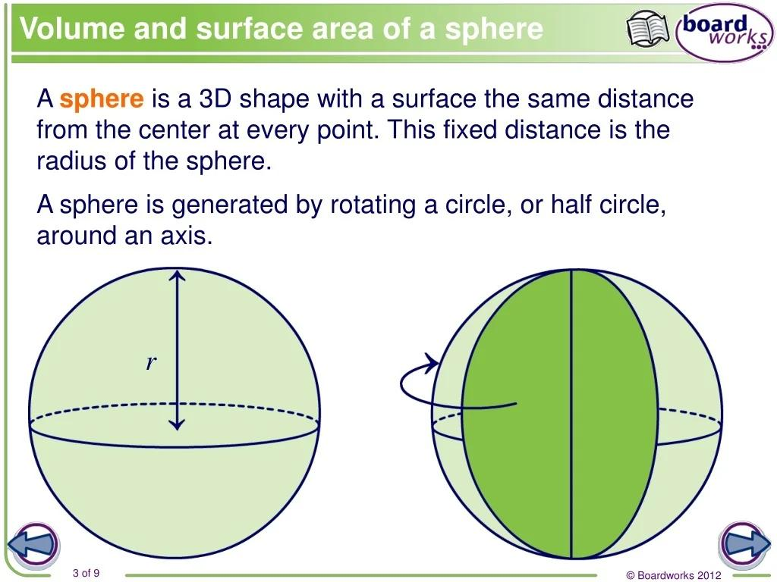
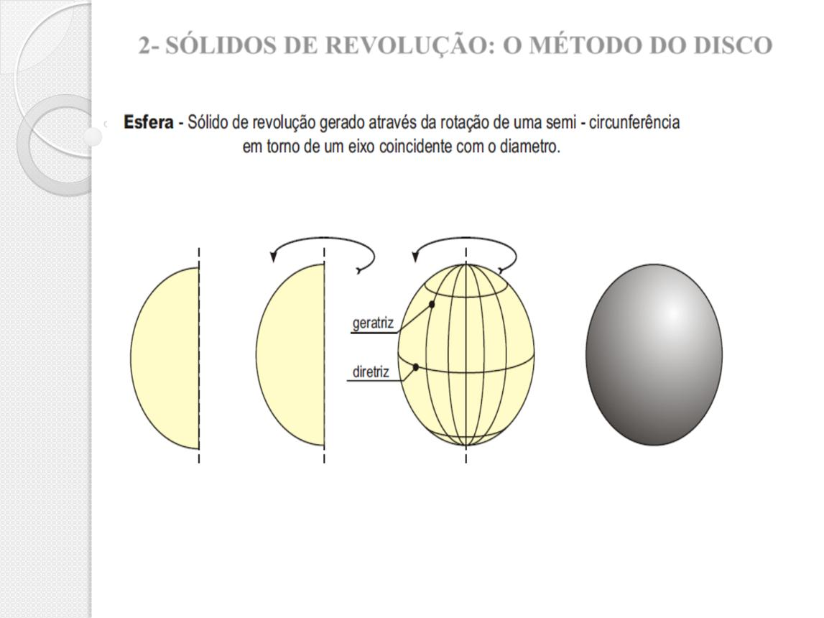

Definition
# Source: AI Source: Provided by: [Data Path: Persons Table -> ID Column: 1, Name_En Column: Motasem Essam] -> From: [ChatGPT] on [7/25/2026]
A sphere of revolution is a three-dimensional solid generated by rotating a semicircle through ${360}^{∘}$ about its diameter.
As the semicircle rotates around the diameter, its curved boundary sweeps out a spherical surface, while the semicircular region sweeps out the entire solid sphere.
The diameter of the generating semicircle becomes the axis of revolution, and its radius becomes the radius of the resulting sphere.

Simple Definition
# Source: AI Source: Provided by: [Data Path: Persons Table -> ID Column: 1, Name_En Column: Motasem Essam] -> From: [ChatGPT] on [7/25/2026]
A sphere of revolution is a perfect sphere created by spinning a semicircle around its straight edge, which is its diameter.

How a Sphere of Revolution Is Formed
# Source: AI Source: Provided by: [Data Path: Persons Table -> ID Column: 1, Name_En Column: Motasem Essam] -> From: [ChatGPT] on [7/25/2026]
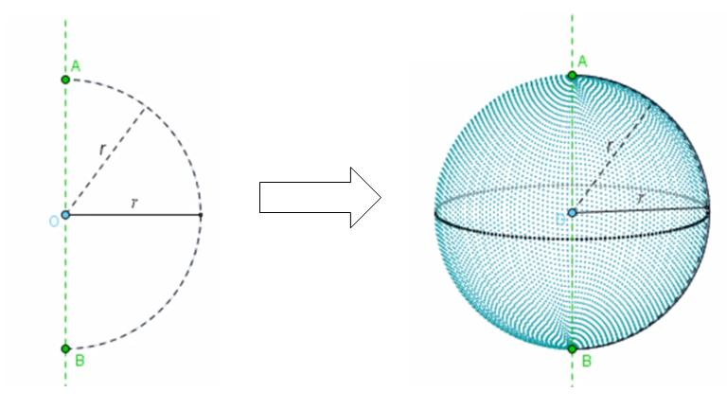
The construction follows these steps:
- Draw a semicircle with radius $R$.
- Identify its diameter as the axis of rotation.
- Rotate the semicircle around that diameter.
- Continue the rotation through a complete ${360}^{∘}$.
- The semicircular region sweeps out a solid sphere.
The result is a sphere with a constant radius $R$ in every direction from its center.

Geometric Components
# Source: AI Source: Provided by: [Data Path: Persons Table -> ID Column: 1, Name_En Column: Motasem Essam] -> From: [ChatGPT] on [7/25/2026]
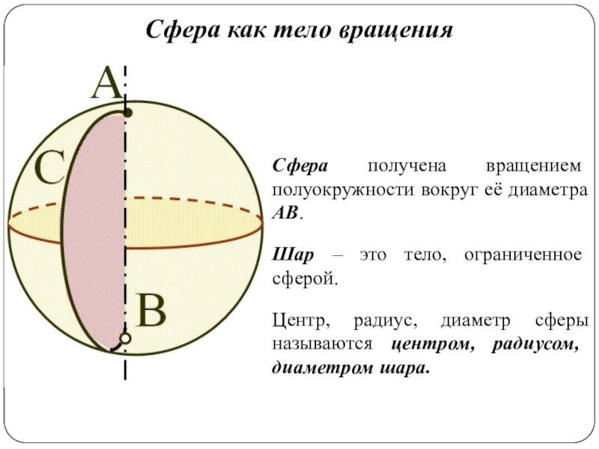
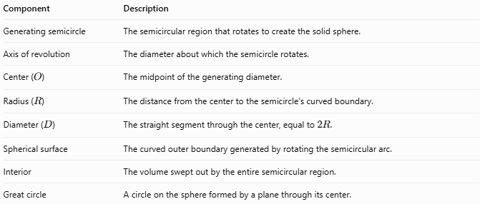
Component | Description
Generating semicircle | The semicircular region that rotates to create the solid sphere.
Axis of revolution | The diameter about which the semicircle rotates.
Center ($O$) | The midpoint of the generating diameter.
Radius ($R$) | The distance from the center to the semicircle's curved boundary.
Diameter ($D$) | The straight segment through the center, equal to $2R$.
Spherical surface | The curved outer boundary generated by rotating the semicircular arc.
Interior | The volume swept out by the entire semicircular region.
Great circle | A circle on the sphere formed by a plane through its center.

Key Characteristics
# Source: AI Source: Provided by: [Data Path: Persons Table -> ID Column: 1, Name_En Column: Motasem Essam] -> From: [ChatGPT] on [7/25/2026]
- A sphere of revolution is a three-dimensional solid.
- It is generated by a complete ${360}^{∘}$ rotation of a semicircle about its diameter.
- The axis of revolution passes through the center.
- Every point on the spherical surface is at the same distance $R$ from the center.
- The resulting solid is perfectly spherical, not oblate or prolate.
- Any diameter through the center can serve as an axis of revolution.
- Rotating only the semicircular arc generates the spherical surface; rotating the entire semicircular region generates the solid.

Mathematical Formulas
# Source: AI Source: Provided by: [Data Path: Persons Table -> ID Column: 1, Name_En Column: Motasem Essam] -> From: [ChatGPT] on [7/25/2026]
Because a sphere of revolution is a perfect sphere, it uses the standard sphere formulas.

Radius and Diameter
# Source: AI Source: Provided by: [Data Path: Persons Table -> ID Column: 1, Name_En Column: Motasem Essam] -> From: [ChatGPT] on [7/25/2026]
$$\boxed{D=2R}$$
$$\boxed{R=\frac{D}{2}}$$

Surface Area
# Source: AI Source: Provided by: [Data Path: Persons Table -> ID Column: 1, Name_En Column: Motasem Essam] -> From: [ChatGPT] on [7/25/2026]
$$\boxed{A=4πR^{2}}$$

Volume
# Source: AI Source: Provided by: [Data Path: Persons Table -> ID Column: 1, Name_En Column: Motasem Essam] -> From: [ChatGPT] on [7/25/2026]
$$\boxed{V=\frac{4}{3}πR^{3}}$$

Circumference of a Great Circle
# Source: AI Source: Provided by: [Data Path: Persons Table -> ID Column: 1, Name_En Column: Motasem Essam] -> From: [ChatGPT] on [7/25/2026]
$$\boxed{C=2πR}$$

Cartesian Equation
# Source: AI Source: Provided by: [Data Path: Persons Table -> ID Column: 1, Name_En Column: Motasem Essam] -> From: [ChatGPT] on [7/25/2026]
For a sphere centered at the origin:
$$\boxed{x^{2}+y^{2}+z^{2}=R^{2}}$$
For a sphere centered at $\left(h,k,l\right)$:
$${\left(x-h\right)}^{2}+{\left(y-k\right)}^{2}+{\left(z-l\right)}^{2}=R^{2}$$

Worked Examples
# Source: AI Source: Provided by: [Data Path: Persons Table -> ID Column: 1, Name_En Column: Motasem Essam] -> From: [ChatGPT] on [7/25/2026]
Example 1 — Find the Radius
A sphere of revolution is generated by rotating a semicircle whose diameter is $18\text{ cm}$. Find the sphere's radius.
Solution
$$R=\frac{D}{2}=\frac{18}{2}$$
$$\boxed{R=9\text{ cm}}$$
Example 2 — Calculate the Surface Area
The generating semicircle has a radius of $4\text{ cm}$.
$$A=4πR^{2}$$
$$A=4π{\left(4\right)}^{2}=64π$$
$$\boxed{A≈201.06{\text{ cm}}^{2}}$$
Example 3 — Calculate the Volume
A sphere of revolution has a radius of $6\text{ cm}$.
$$V=\frac{4}{3}πR^{3}$$
$$V=\frac{4}{3}π{\left(6\right)}^{3}$$
$$V=288π$$
$$\boxed{V≈904.78{\text{ cm}}^{3}}$$
Example 4 — Identify the Generating Shape
A solid is formed by rotating a semicircular region around its diameter through ${360}^{∘}$.
Answer: The resulting solid is a sphere of revolution. Its generating diameter becomes an axis through the sphere's center.

Comparison with Related Concepts
# Source: AI Source: Provided by: [Data Path: Persons Table -> ID Column: 1, Name_En Column: Motasem Essam] -> From: [ChatGPT] on [7/25/2026]
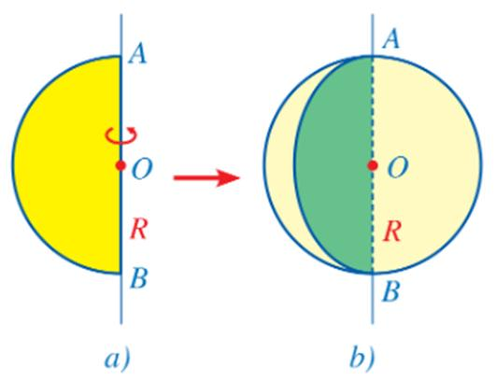
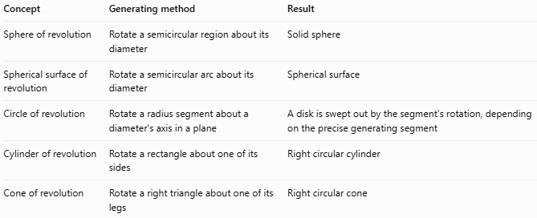
Concept | Generating method | Result
Sphere of revolution | Rotate a semicircular region about its diameter | Solid sphere
Spherical surface of revolution | Rotate a semicircular arc about its diameter | Spherical surface
Circle of revolution | Rotate a radius segment about a diameter's axis in a plane | A disk is swept out by the segment's rotation, depending on the precise generating segment
Cylinder of revolution | Rotate a rectangle about one of its sides | Right circular cylinder
Cone of revolution | Rotate a right triangle about one of its legs | Right circular cone
Important distinction: The sphere of revolution describes how a sphere is generated. The ordinary sphere describes the resulting geometric solid. Both refer to the same shape when the generating semicircle rotates fully around its diameter.

Applications
# Source: AI Source: Provided by: [Data Path: Persons Table -> ID Column: 1, Name_En Column: Motasem Essam] -> From: [ChatGPT] on [7/25/2026]
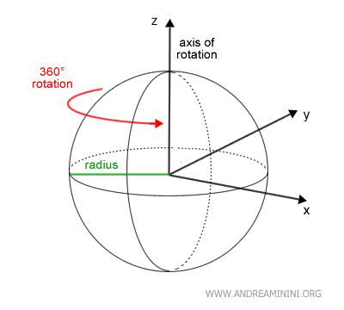
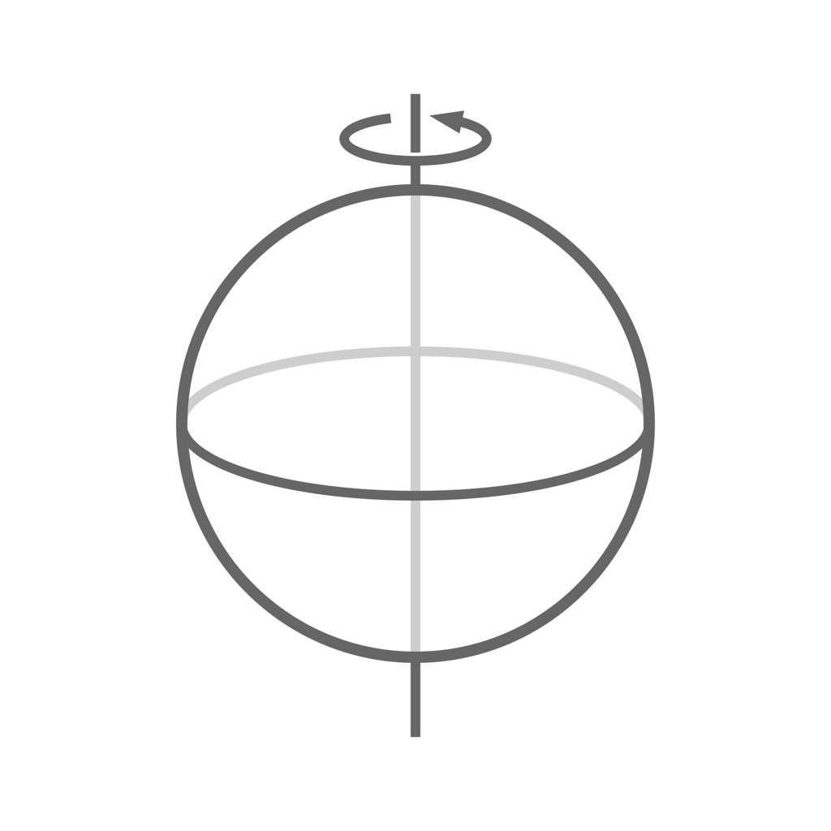
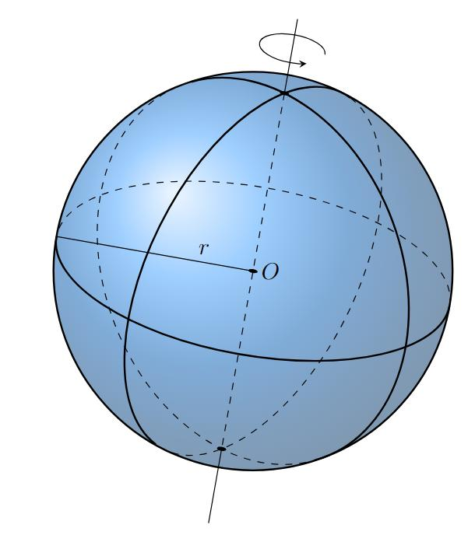
- Geometry education: Demonstrates how two-dimensional regions can generate three-dimensional solids.
- Calculus: Illustrates solids of revolution and volume calculations.
- Engineering: Helps model spherical components such as balls and spherical containers.
- Computer graphics: Supports the mathematical construction and rendering of sphere-shaped objects.
- Physics: Provides an idealized spherical model for objects and systems with spherical symmetry.

Key Points
# Source: AI Source: Provided by: [Data Path: Persons Table -> ID Column: 1, Name_En Column: Motasem Essam] -> From: [ChatGPT] on [7/25/2026]
- A sphere of revolution is formed by rotating a semicircular region about its diameter.
- The rotation is through ${360}^{∘}$.
- The axis of revolution passes through the center.
- The generating radius equals the resulting sphere's radius.
- Rotating the arc creates the spherical surface; rotating the region creates the solid.
- The volume is $\frac{4}{3}πR^{3}$.
- The surface area is $4πR^{2}$.
- The result is a perfect sphere with equal radii in all directions.

Conclusion
# Source: AI Source: Provided by: [Data Path: Persons Table -> ID Column: 1, Name_En Column: Motasem Essam] -> From: [ChatGPT] on [7/25/2026]
A sphere of revolution is a perfect sphere generated by rotating a semicircle around its diameter. It demonstrates the relationship between a two-dimensional generating region and a three-dimensional solid. Its geometry, surface area, and volume are identical to those of any ordinary sphere.

